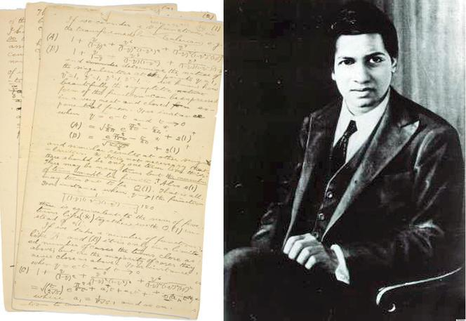
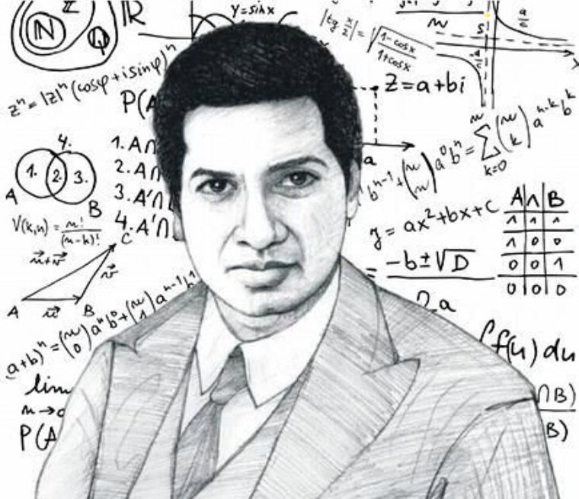
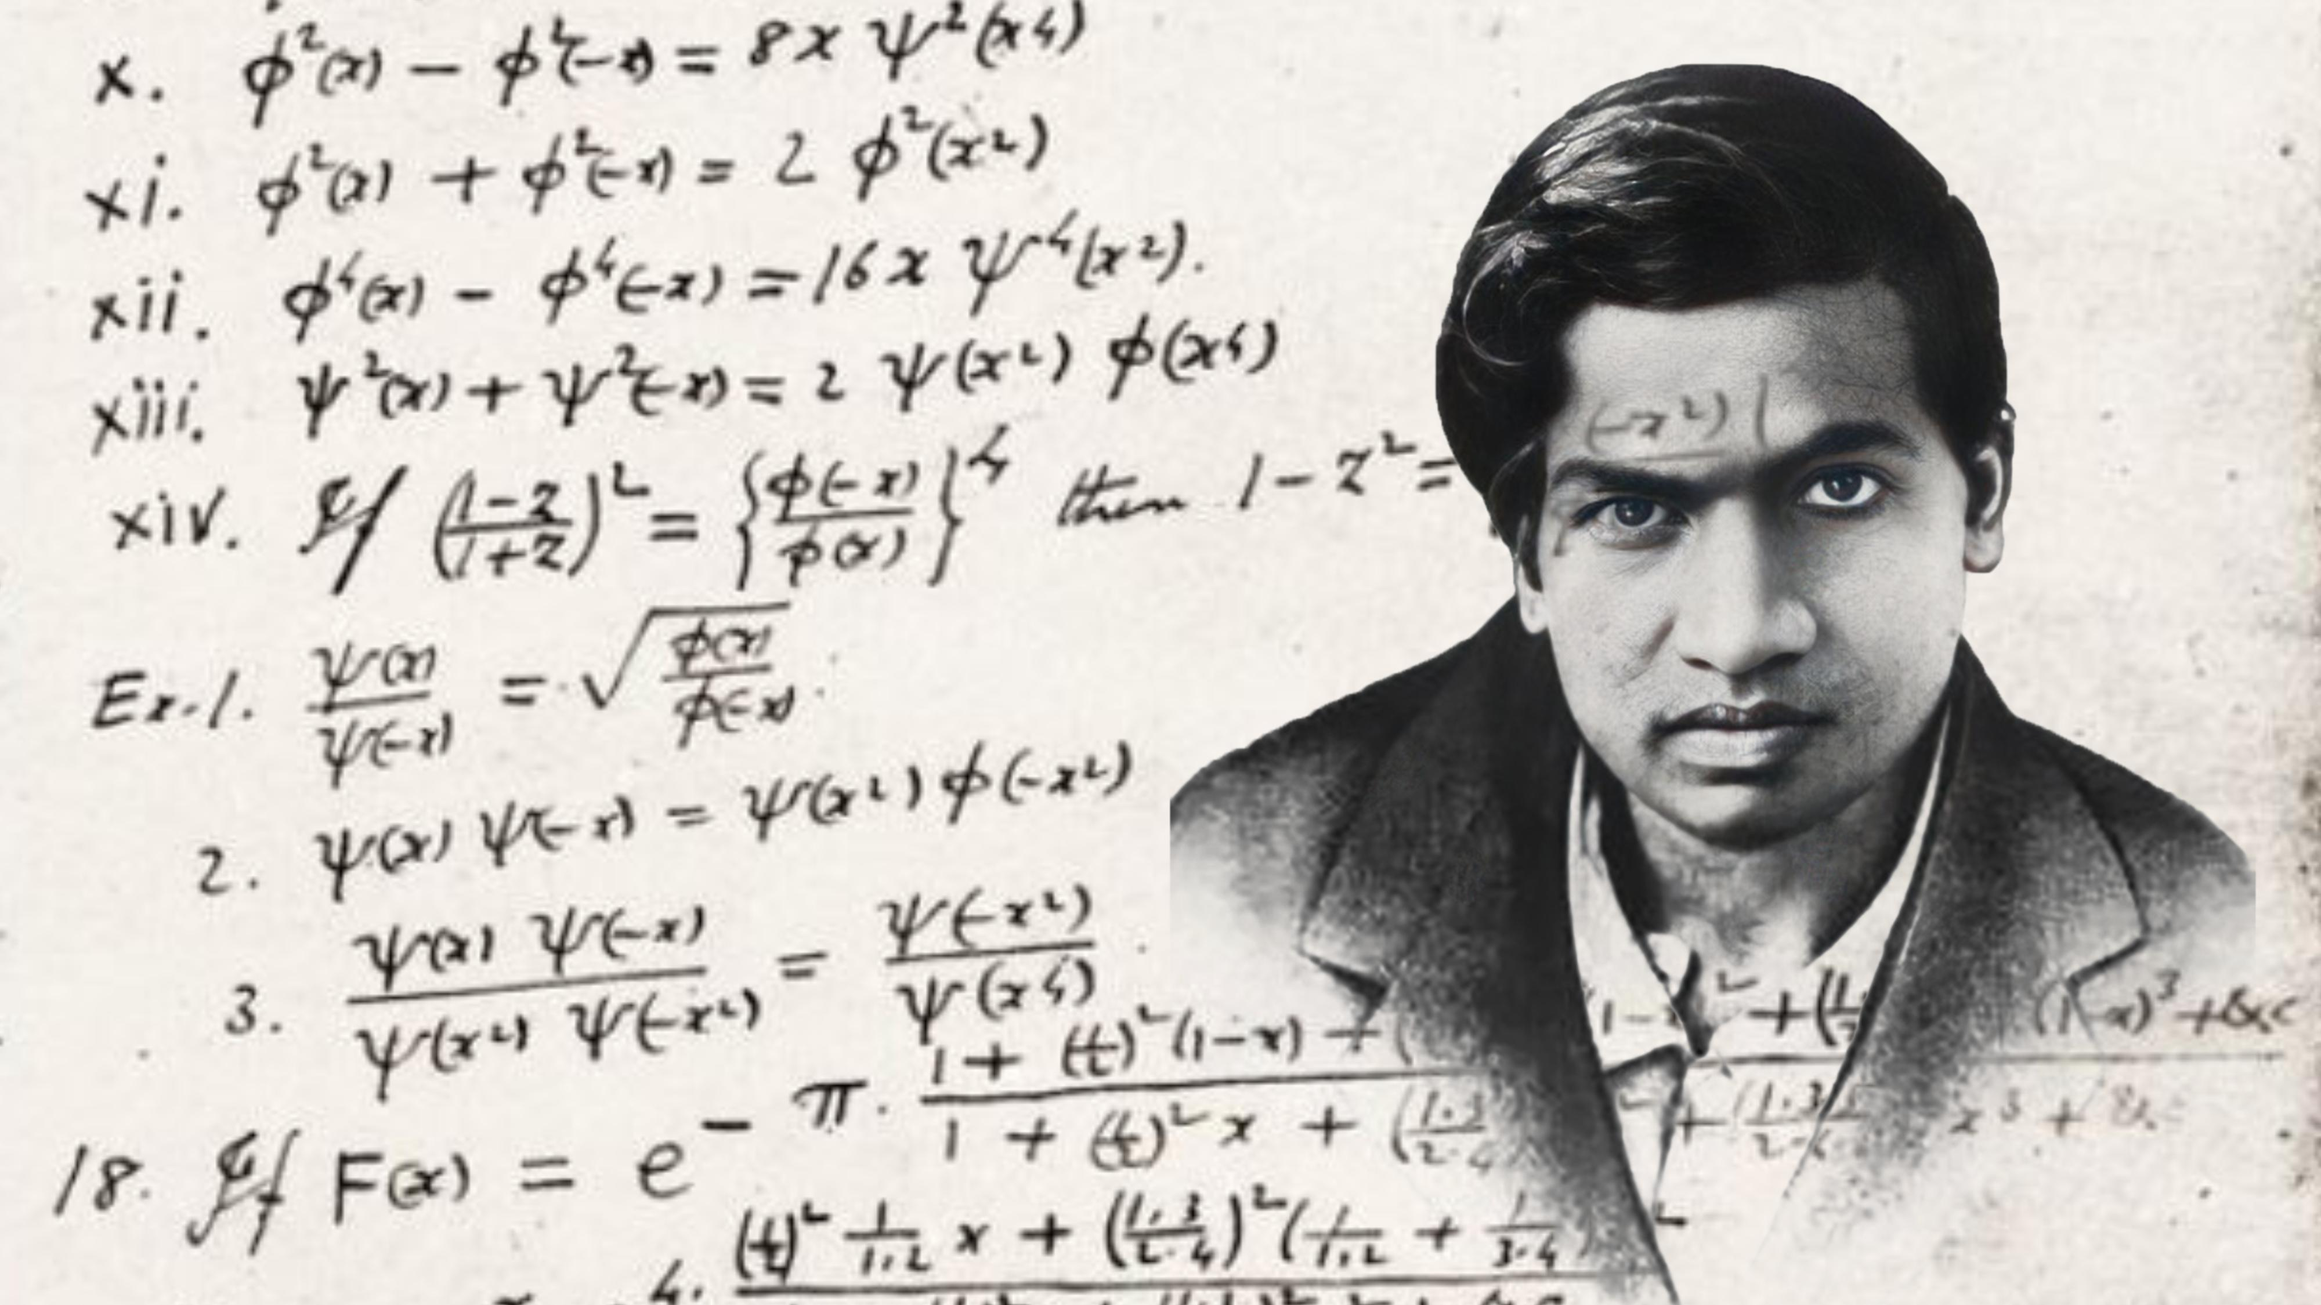
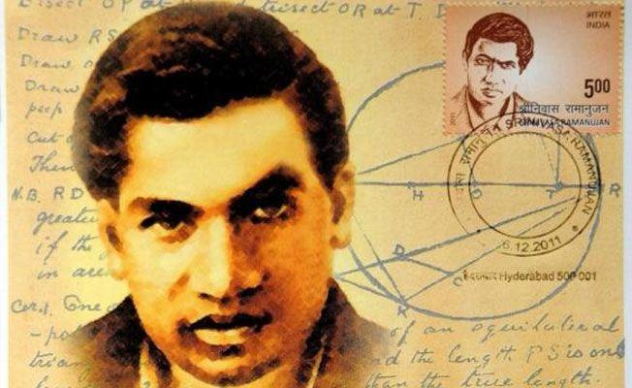
Srinivasa Ramanujan became a mathematician through a rare combination of self-study, obsession, memory, intuition, and relentless practice—not through a standard university path.

How he started

1. Early talent in school
As a child in Kumbakonam, he was unusually strong in arithmetic and patterns. Teachers noticed he could solve problems faster than classmates.
He became fascinated with:
- numbers
- series
- fractions
- puzzles
- mental calculation

The turning point: one book
Around age 16, he got a copy of:
A Synopsis of Elementary Results in Pure and Applied Mathematics
This book contained thousands of theorems and formulas with little or no proofs. It was like a compressed formula encyclopedia.

Why this mattered
Most students need:
theory → proofs → exercises
Ramanujan instead got:
results → patterns → reconstruction
So he tried to derive everything himself.

How he learned initially

1. Reverse engineering formulas
He would see a result and ask:
- Why is this true?
- Can it be generalized?
- What happens for larger numbers?
- Is there a hidden pattern?
That trained him like a researcher.

2. Massive notebook practice
He filled notebooks with:
- identities
- infinite series
- continued fractions
- partition formulas
- approximations

3. Deep intuition with numbers
He mentally experimented with examples until patterns became visible.

Why formal education failed him
He entered college, but focused almost entirely on mathematics and neglected other subjects, so he lost scholarships and struggled academically in the conventional system.

How he became world-known
He later wrote to G. H. Hardy with pages of original formulas. Hardy recognized extraordinary genius and brought him to University of Cambridge.

In simple words
Ramanujan became a mathematician by:
- loving numbers early
- getting one dense formula book
- teaching himself relentlessly
- discovering patterns others missed
- working nonstop despite hardship

Important truth
He did not learn like most people.
He learned by exploration first, proof later.

If you’d like, I can also explain what exact mental method Ramanujan likely used daily to discover formulas (something modern learners can imitate).




Srinivasa Ramanujan became a mathematician through a rare combination of self-study, obsession, memory, intuition, and relentless practice—not through a standard university path.

How he started

1. Early talent in school
As a child in Kumbakonam, he was unusually strong in arithmetic and patterns. Teachers noticed he could solve problems faster than classmates.
He became fascinated with:
- numbers
- series
- fractions
- puzzles
- mental calculation

The turning point: one book
Around age 16, he got a copy of:
A Synopsis of Elementary Results in Pure and Applied Mathematics
This book contained thousands of theorems and formulas with little or no proofs. It was like a compressed formula encyclopedia.

Why this mattered
Most students need:
theory → proofs → exercises
Ramanujan instead got:
results → patterns → reconstruction
So he tried to derive everything himself.

How he learned initially

1. Reverse engineering formulas
He would see a result and ask:
- Why is this true?
- Can it be generalized?
- What happens for larger numbers?
- Is there a hidden pattern?
That trained him like a researcher.

2. Massive notebook practice
He filled notebooks with:
- identities
- infinite series
- continued fractions
- partition formulas
- approximations

3. Deep intuition with numbers
He mentally experimented with examples until patterns became visible.

Why formal education failed him
He entered college, but focused almost entirely on mathematics and neglected other subjects, so he lost scholarships and struggled academically in the conventional system.

How he became world-known
He later wrote to G. H. Hardy with pages of original formulas. Hardy recognized extraordinary genius and brought him to University of Cambridge.

In simple words
Ramanujan became a mathematician by:
- loving numbers early
- getting one dense formula book
- teaching himself relentlessly
- discovering patterns others missed
- working nonstop despite hardship

Important truth
He did not learn like most people.
He learned by exploration first, proof later.

If you’d like, I can also explain what exact mental method Ramanujan likely used daily to discover formulas (something modern learners can imitate).
Yes — the book most often credited as the spark for Srinivasa Ramanujan was:
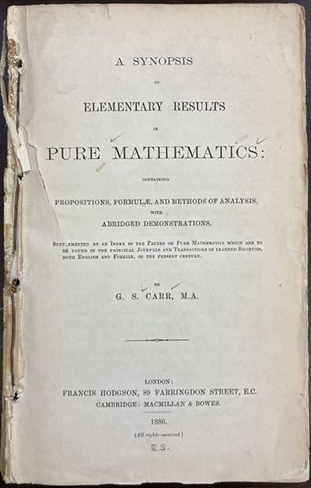
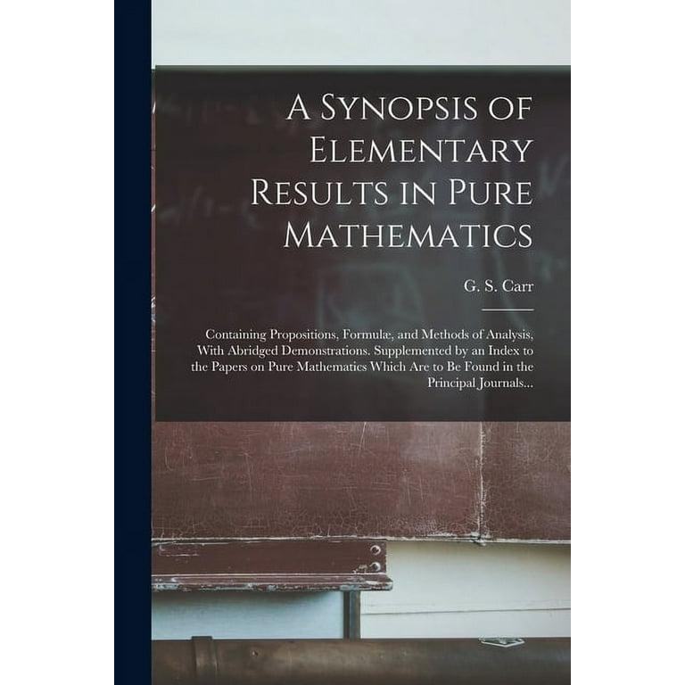
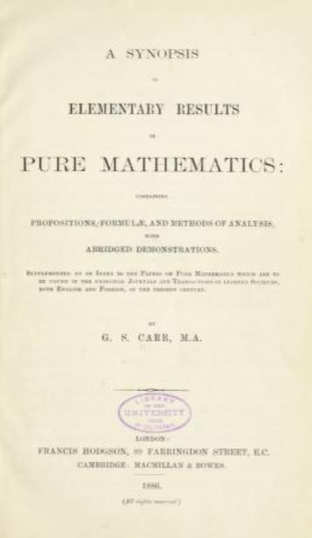
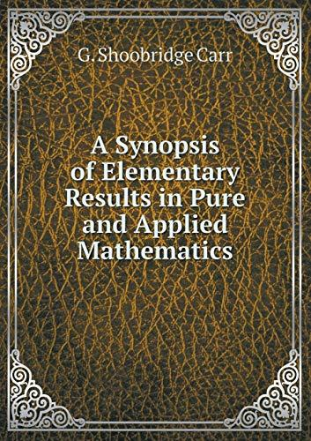
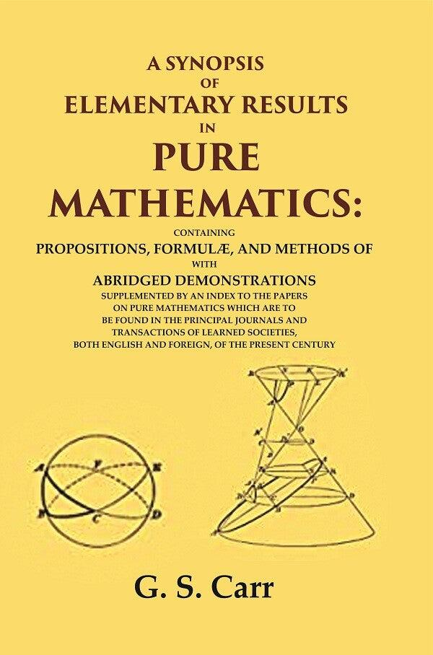
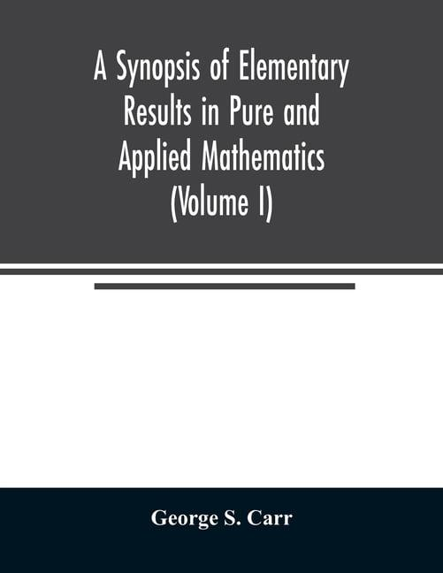
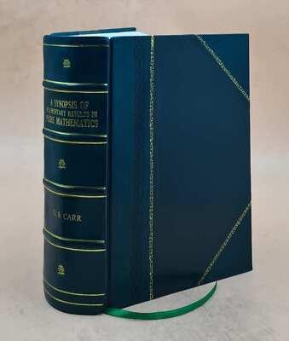
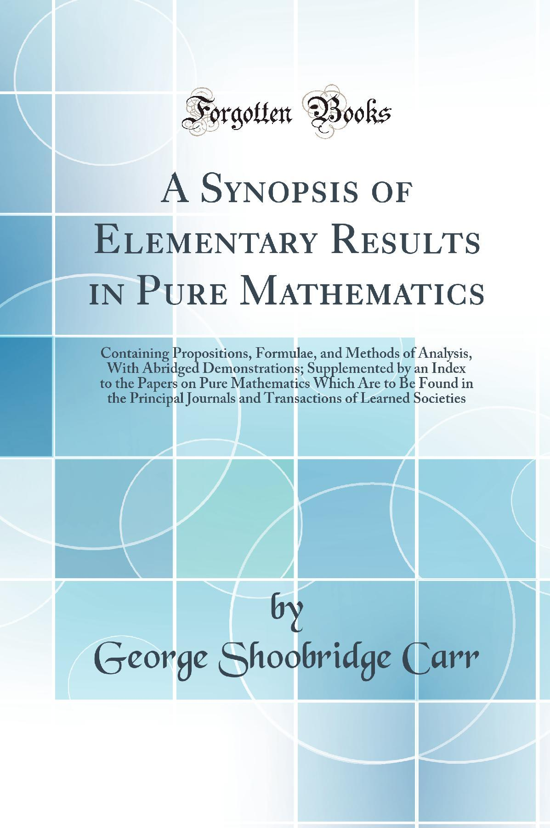
A Synopsis of Elementary Results in Pure and Applied Mathematics by George Shoobridge Carr.

What kind of book it was
It was not a normal textbook. It was more like:
- thousands of formulas
- theorems listed briefly
- very short hints
- little explanation
- little proof
Think of it as a compressed mathematics handbook.

Why it was perfect for Ramanujan
Most students would find it hard or dry.
Ramanujan used it as a challenge:
“Can I rediscover why this is true?”
That process likely trained his genius.

Example style of content
It would state results like:
1+2+3+\cdots+n=\frac{n(n+1)}{2}
or identities, series, trigonometric results, calculus formulas—often without full derivations.

Why historically important
One ordinary summary book reached an extraordinary mind and changed mathematics.

If you want, I can also tell you how to study Carr’s book today like Ramanujan did, or where to download a free copy legally.

Yes — that line captures a profound learning model.
For Srinivasa Ramanujan, the flow was likely:

Standard learning path
Most people learn:
definitions → theory → proofs → exercises → results
You are guided step by step.

Ramanujan-style path
He often encountered:
results → patterns → reconstruction
Meaning:

1. Results
He saw finished formulas/theorems in Carr’s book, such as identities, sums, series, approximations.
Example:
1+2+3+\cdots+n=\frac{n(n+1)}{2}

2. Patterns
He compared many formulas and noticed recurring structures:
- symmetry
- repetition
- coefficients
- growth behavior
- transformations

3. Reconstruction
He likely asked:
- How was this discovered?
- Can I derive it differently?
- Can I generalize it?
- What happens for infinity?
- Is there a deeper hidden relation?
Then rebuilt the mathematics himself.

Why this is powerful
Because reconstruction trains:
- deep understanding
- creativity
- proof intuition
- pattern recognition
- original thinking
It turns learner → discoverer.

Engineering Analogy
Instead of learning how an engine works chapter by chapter:
You inspect a finished engine, detect patterns, dismantle it mentally, and redesign it.
That accelerates insight.

Why Ramanujan became exceptional
Many students solve known problems.
Ramanujan trained on:
unknown route from answer back to principle
That resembles research.

Can normal people use this method?
Yes.
For any topic:
- Look at final theorem/result
- Study examples
- Guess hidden rules
- Re-derive from basics
- Extend/generalize

One-line summary
Ramanujan often learned not by being led to answers, but by meeting answers first and discovering the road backward.

